# 

**New Cross College**

**Assessment and Reporting Policy**

***Mission Statement:***

Our school is a Catholic Voluntary Secondary School that aims to provide a safe, inclusive, academic environment shaped by mutual respect.

We respect the dignity of the individual person and are sensitive to the needs of a diverse society.

We aim to make our school a happy and caring environment which recognises the needs of each individual. We believe that education flourishes in a school where good relationships are encouraged, where people feel valued and there is tolerance, fairness and support for those in difficulty.

We believe in helping all to develop their confidence, self-esteem and talents so that they may take their place in society as responsible and mature young adults.

***1.0 Introduction:***

Teaching, assessment, learning and reporting are the four pillars that aim to contribute to the personal and educational development of our students in New Cross College. As a school we recognise that parents, teachers and students need to have an effective learning-focused partnership to ensure the best possible outcomes can be achieved for our students. It is school policy in New Cross College to encourage and support ongoing assessment as part of the teaching and learning process.

***2.0 Reporting*:**

Reporting aims to support and underpin ongoing learning and assessment, and to be manageable, accessible and effective for the school, teacher, student and parent (Junior Cycle Framework, 2015).

***3.0 Assessment*:**

The purpose of assessment is to help the student discover ‘where to go next’ and help the teacher support that growth. Assessment in the widest sense is a snapshot of where a student is at a particular point in time.

In planning for effective assessment and reporting, teachers in New Cross College will use the ***Looking at Our School 2022*** document to support their classroom practice. This document will direct the teacher in the planning, preparation and assessment practices that progress students’ learning. Subject specifications, curriculum and assessment guidelines are all key documents in the planning for assessment and reporting.

***4.0 Inclusive Assessment:***

Inclusive assessment practices are a key feature of teaching and learning in schools. Accommodations, e.g. the support provided by an Additional Needs Assistant or the support of assistive technologies, should be in line with the arrangements the school has put in place to support the student’s learning throughout the year. Where a student has a specific physical or learning difficulty, reasonable accommodations will be put in place to remove, as far as possible, the impact of the disability on the student’s performance in their assessments. Accommodations which enable all students to access learning and assessment are based on specific needs.

***5.0 Ongoing Reporting in New Cross College:***

Ongoing reporting on student progress can take a variety of forms in New Cross College

* Informal oral and written feedback
* Student Journal
* Parent teacher meetings
* Discussions with class teacher/Year Head/A.E. N coordinator
* Student learning logs, diaries, reflections
* End of topic/term/year reports
* Communication and engagement with parents/guardians via telephone, student journal, VSware, post, newsletter
* Student’s Behaviour Record on VSWare
* Students’ learning progress and achievement in subjects and short courses
* Engagement with the learning behaviours and disposition of students
* The wellbeing of students.
* Student participation and achievement in extra-curricular activities
* The results of classroom-based-assessments (CBA’S)
* Areas such as punctuality, behaviour and attendance

***6.0 The guiding principles of reporting and effective reporting in New Cross College***:

* Encourages authentic engagement with parents
* Provides opportunities for students to reflect on their learning through feedback
* Values the professional judgements of teachers
* Uses the language of learning to provide effective feedback
* Is manageable and does not take away from learning and teaching
* Clearly communicates students’ progress in learning
* Provides information on a broad range of achievement
* Is sensitive to the self-esteem and general wellbeing of students and takes an inclusive approach. (NCCA, 2018)

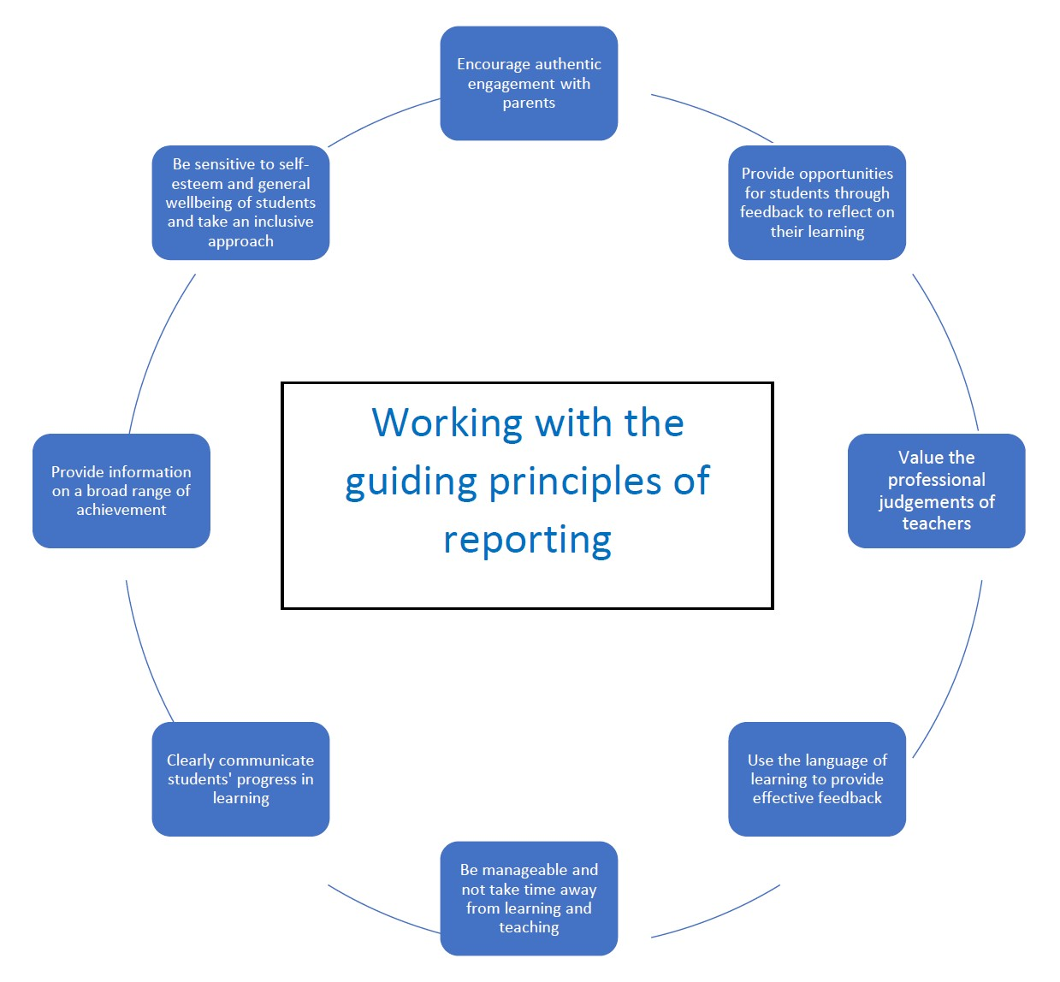

***7.0 Types of Assessment in New Cross College*** – ***See Glossary for further details***

* Formative Assessment
* Summative Assessment
* Classroom Based Assessments
* Oral and Aural assessments in languages
* Assessment Tasks
* Project Work – Presentations, PowerPoints, Eportfolios, visual displays, posters,
* Practical Exams in Art
* Log Books/Field Study - Science, History, Geography
* Online assessments
* Entrance Exams
* Standardised Tests
* Literacy
* Numeracy

***8.0 Other Modes of Assessment in New Cross College***:

* **8.1: Entrance Assessments:**
* As part of our Admissions Policy incoming first years are asked to take assessment tests once they have started school. The two tests currently used are:

* Cognitive Abilities Test 4 (CAT4) which is made up of a series of short reasoning tests which assess the student’s reasoning abilities in key areas.
* New Group Reading Test (NGRT) which assess the reading age of incoming students.
* The information gathered will be used to form mixed ability classes in first year. This assessment offers an early indicator of a student’s potential ability. They are also an indicator of students who may need further support.

* **8.2: Maths and Reading Age tests:**

All students in first, second and third year will be tested to assess their reading and mathematical ages each academic year, this includes the 1st year entrance test.

* **8.3 Fitness tests**:

These are taken as part of the PE curriculum to encourage healthy eating and exercise.

* **8.4: A.E.N Department Assessments:**

If a student is identified as needing additional support the AEN Co-ordinator will apply to the National Council for Special Education (NCSE) for that assistance. Classroom strategies such as differentiated assessment, team teaching, one-to-one tuition, visual aids, spelling waivers, increased time and dictionaries amongst others, may be used from time to time, as determined by the AEN Co-ordinator in consultation with individual subject teachers. The psychologist from the National Educational Psychological Service (NEPS) assigned to New Cross College, in consultation with school management, may carry out psychological assessments and other assessments on students at different times of the year.

* **8.6 Aptitude Tests**:

Transition year students will complete CAT4 tests. This will assist students to focus on their strong subjects with a view to continuing these onto Leaving Certificate and beyond. It is hoped these results will guide students in making their subject choices heading into Leaving Certificate.

***9.0 Glossary of Terms***

|  |  |
| --- | --- |
| Assessment | Assessment is the process of generating, gathering, recording, interpreting, using and reporting evidence of learning in individuals, groups or systems. Educational assessment provides information about progress in learning, and achievement in developing skills, knowledge, behaviours and attitudes. |
| Assessment Task | The Assessment Task is a written task completed by students during class time and is sent to the State Examinations Commission for marking. The Assessment Task is specified by the NCCA and is related to the learning outcomes of the second Classroom-Based Assessment. The Guidelines for the Classroom-Based Assessments and Assessment Task for each subject will provide all the necessary details and they are also available in the Assessment Toolkit. |
| Assessment Method | This is a term that encompasses the various strategies and techniques that can be used to collect information from students about their progress towards attaining the knowledge, skills and attitudes to be learned. The assessment method chosen should allow for the generation of evidence and provision of timely feedback in order to make appropriate instructional decisions and improve student learning. |
| Blended Learning | This refers to the practice of using both online and real-time learning experiences when teaching students. This combination of content delivery allows for both methods to support and complement each other and personalise the learning process. This can also be referred to as 'hybrid learning' or 'mixed mode learning'. |
| Classroom Based  Assessment CBA | Classroom-Based Assessments in subjects and short courses provide students with opportunities to demonstrate their understanding and skills in ways not possible in a formal examination. Classroom-Based Assessments, facilitated by the classroom teacher, are undertaken by students in a defined time period, within class contact time and to a national timetable. (Click 'subjects' on the left for further subject specific information). |
| Diagnostic Assessment | This is a type of assessment that is intended to diagnose the strengths and/or areas of need in students prior to a learning activity. It allows for the identification and provision of the appropriate interventions and pedagogical approaches necessary to scaffold the learning to meet the individual learning needs of students. |
| Differentiated Instruction | Differentiated instruction refers to the wide range of strategies, techniques and approaches that are used to support student learning and help every student to achieve and to realise his or her potential. |
| Examples of student work | Annotated samples of authentic student work are published online to illustrate levels of achievement in relation to features of quality. They are developed so that teachers, parents, students and other stakeholders can familiarise themselves with achievement levels. |

|  |  |
| --- | --- |
| Expectations for  Learners/Students | An umbrella term that links learning outcomes with annotated examples of student work and demonstrates the extent to which the learning outcomes are being realised. |
| Features of Quality | Features of quality are the statements in the short course/subject specifications that support teachers in making judgements about the quality of student work for the purpose of awarding achievement grades for certification. As success criteria are closely linked to learning intentions and based on the day-to-day processes in the classroom, student learning will gradually come to reflect the requirements set out in the features of quality which are used for assessment and reporting purposes. |
| Formative Assessment | Assessment is formative when either formal or informal procedures are used to gather evidence of learning during the learning process, and used to adapt teaching to meet student needs. The process permits teachers and students to collect information about student progress and to suggest adjustments to the teacher’s approach to instruction and the student’s approach to learning. Assessment for learning covers all aspects of formative assessment but has a particular focus on the student having an active role in his/her learning. |
| Individual Education  Plans | Plans developed in schools which detail the teaching and learning approaches intended to address the distinct learning needs, interests and aspirations of individual students. |
| Junior Cycle Profile of Achievement | The JCPA is the award that students will receive at the end of their junior cycle. The award will reward achievement across all areas of learning and assessment including ongoing, formative assessment; Classroom-Based Assessments; and SEC grades, which include results from the final examinations and the  Assessment Tasks. |
| Learning Intention | A learning intention for a lesson or series of lessons is a statement, created by the teacher, which describes clearly what the teacher wants the students to know, understand and be able to do as a result of the learning and teaching activities. |
| Learning Outcome | Learning outcomes are statements in curriculum specifications to describe the knowledge, understanding, skills and values students should be able to demonstrate after a period of learning. |
| Moderation | Moderation is a collaborative process that enables teachers to reach consistency in their judgements of student work against agreed success criteria or features of quality. The moderation process involves teachers discussing the qualities demonstrated in examples of student work to reach agreement about the standard of that work. |
| Ongoing Assessment | As part of their classroom work, students engage in assessment activities that can be either formative or summative in nature. Teachers assess as part of their daily practice by observing and listening as students carry out tasks, by looking at what they write and make, and by considering how they respond to, frame and ask questions. Teachers use this assessment information to help students plan the next steps in their learning. Periodically, this assessment will be in more structured, formalised settings where teachers will need to obtain a snapshot of the student’s progress in order to make decisions on future planning and to report on progress. This may involve the students in doing projects, |
|  | investigations, case studies and/or tests and may occur at defined points in the school calendar. |
| Peer Assessment | Peer assessment is the assessment of the work of others of equal status. In the context of student learning, peer assessment is used by students to estimate the worth of other student’s work with reference to specific and agreed criteria. |
| Reliability | This is the extent to which the assessment would give the same result if repeated. Reliability in assessment means that high quality evidence and information is provided on student performance and is comparable (i.e. it stands up when compared to judgements across learners, departments and schools). |
| Reporting | The communication of information on the results of assessment of student achievement. |
| Self-Assessment | Self-assessment is the involvement of students in making judgements about their own work, based on features of quality. It is a measure of the extent to which their own work has met these features of quality. |
| Specification | A subject or short course specification details the intended learning outcomes, and how they can be achieved and demonstrated. The specification outlines how the learning in any subject or short course is linked to particular statements of learning and key skills. |
| Standardised Test | This is a test that is given in a consistent way to all the test takers and uses uniform procedures for administration and scoring. This term is primarily associated with large-scale tests administered to sizeable populations of students, and allows for comparison of relative performance of individual students or groups of students. These tests will provide an additional indicator of student progress and are devised to supplement and not replace the teacher's professional judgement. |
| Subject Learning  Assessment and Review  (SLAR) Meeting | Following the completion of a Classroom-Based Assessment, teachers will engage in review meetings, where they will share and discuss samples of their assessments of student work and build common understanding about the quality of student learning. |
| Success Criteria | Success criteria are linked to learning intentions. They are developed by the teacher and/or the student and describe what success looks like. They help the teacher and student to make judgements about the quality of student learning. |
| Summative Assessment | Assessment is summative when it is used to evaluate student learning at the end of the instructional process or of a period of learning. The purpose is to summarise the students’ achievements and to determine whether and to what degree the students have demonstrated understanding of that learning by comparing it against agreed success criteria or features of quality. |
| Validity | This is the degree to which an assessment instrument accurately measures what it was designed to measure. |

***10.0 Reporting Descriptors for Programmes:***

* **10.1: Reporting Descriptors for Junior Cycle**

|  |  |
| --- | --- |
| New Junior Cycle Subject Grade Descriptors | |
| Distinction | > 90 to 100 |
| Higher Merit | > 75 and < 90 |
| Merit | > 55 and < 75 |
| Achieved | > 40 and < 55 |
| Partially Achieved | > 20 and < 40 |
| Not Graded (NG) | > 0 and < 20 |

* **10.2: Reporting Descriptors for Junior Cycle CBA’s**

|  |
| --- |
| Classroom-Based Assessment Descriptors |
| Exceptional |
| Above Expectations |
| In line with Expectations |
| Yet to Meet Expectations |

* **10.3: Reporting Descriptors for Transition Year**

|  |  |
| --- | --- |
| Distinction | 85-100% |
| Merit | 60-84% |
| Pass | 40-59% |
| Fail | 0-39% |

* **10.4: Reporting Descriptors for Leaving Certificate**

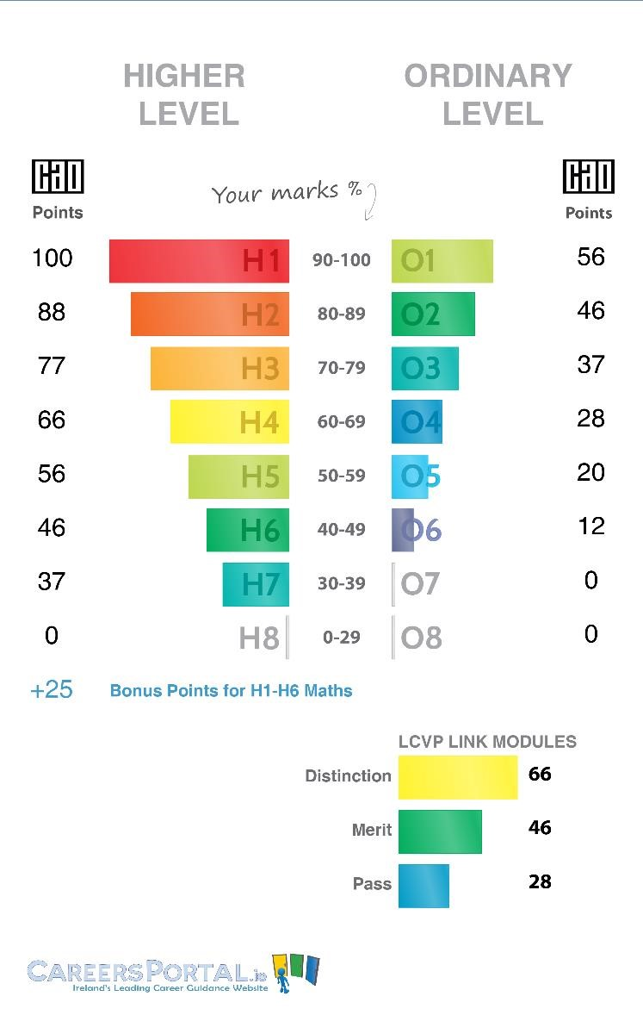

* **10.5: Reporting Descriptors for Leaving Certificate Applied**

|  |  |  |  |
| --- | --- | --- | --- |
| Level |  |  | Marks and Credits Required |
| Marking system grades  Pass | for | examination | 60-69% (120-139 credits) |
| Merit |  |  | 70-84% (140-169 credits) |
| Distinction |  |  | 85-100% (170-200 credits) |

***11.0: Formal Assessment Calendar:***

|  |  |
| --- | --- |
| 1st Year | CAT 4 – October  NGRT and WRAT  Winter Assessments: November  Summer Exams - May  Parent Teacher Meeting – 19th October (subject to change) |
| 2nd Year | NGRT and WRAT  Winter Assessments - November  Summer Exam - May  CBA’s: Can be done in place of formal exam  Parent Teacher Meeting – 23rd November (subject to change) |
| 3rd Year | NGRT and WRAT  Winter Assessments/CBA 2 - November  Assessment Task in relevant Junior Cycle subjects – see CBA calendar  Parent Teacher Meeting – 18th January (subject to change)  Mock Exams – 19th Feb  Practical Exam – State Examinations Commission – March/April  Oral Exam – March/April  CAT4 – Level G  Junior Cycle State Exam - June |
| TY/LCA | Winter Assessments: November -Core subjects in class time  Presentation of TY Portfolio at the end of the school year  Parent Teacher Meeting – 19th October (subject to change)  Summer Exams – May- Core subjects in class time.  LCA assessment - end of session credit awards dependent on module completion and attendance criteria being met.  LCA also partake in DES task interviews, written examinations and practical exams. |
| 5TH Year | Winter assessments-November  Parent Teacher Meeting – 23rd November (subject to change)  Summer Exams - May |
| 6th Year | Parent Teacher Meeting – 18th January (subject to change)  Winter Assessments: November  Mock Exams :19th February  State Examinations - June |

***12.0: State Examinations***

The Junior and Leaving Certificate state examinations are conducted by the State Exams Commission (SEC) nationally for third year and sixth year students respectively and are held each June. For third year students these results can inform their subject choices for senior cycle whilst for sixth year students the results can lead to career path opportunities for their future.

***12.1: State Examination Results and National Average Comparison***

At subject department level teachers are required to compare their Junior Cycle and Leaving Certificate results to the National average. The differential in the results are reported in the minutes of subject department meetings and strategies for improvements are outlined and discussed. Teachers are asked to collaborate and reflect on the results and set measurable targets that can lead to incremental improvements. Areas of good practice should be identified to ensure these results are maintained.

***12.2: Moderation of Winter and Summer Assessments:***

The moderation of Summer and Christmas exams is best practice and this takes places where possible. Moderation ensures that we are adhering to a national standard required for assessment rather than a school-based standard which is key and in line with the SEC. Samples of standards / model answers should be taken into consideration when marking all exams. These can be accessed on www.examinations.ie with the Chief Examiners report key to this process. Standardised exemplars can be made/ used to ensure that grading is kept in line with the national standard. These samples are all available on [www.examinations.ie](http://www.examinations.ie/) and www.curriculumonline.ie.

***12.3: Standardised Marking***

In line with moderation, standardised marking is key. Where possible a marking scheme should be set out. It is vital that this is not subjective but a definite descriptor of what is a correct or incorrect answer. It is important therefore when applying overall marks in grading that there is a consensus as to what is ‘very good’ ‘good’ and so on. This can only be achieved when the paper or assessment piece is discussed among the setters and examination teachers. The use of SEC marking schemes and Chief examiners reports play a vital role in this process. This is best practice particularly when common level tests are the norm.

***12.4: Procedures for House Exams***:

* House Exams take place in November and May for all year groups. The purpose of house exams is to allow students to experience a setting similar to that of the State Examinations.
* 2nd Years are allocated 1.5 hours for exams while 3rd years are scheduled for 2 hours in preparation for Mocks. Senior Exams are allocated 2 hours. In Winter assessments 1st years are scheduled for 1 hour exams as this is their first experience of formal house exams.
* The Deputy Principal has the responsibility for the running of the House and Mock examinations. This includes compilation and dissemination of the relevant exam and supervision timetables to both students and staff and ordering of papers and answer booklets.
* The Deputy Principal meets with each class group to give out and go through the timetable and run through the rules and regulations and to answer any questions relating to each exam.
* Prior to the Mock exams the Principal, Deputy Principal and relevant Year Head hold an assembly to advise on study and procedures in relation to the examinations.
* The AEN Co-ordinator advises the Deputy Principal as to the requirements for special centres for the Winter Assessments, Mock Exams and Summer Assessments. On foot of this advice the Deputy Principal locates and staffs the special centres.

***13.0 Adoption of the Policy:***

This policy was adopted by the Board of Management on 6/2/23

This policy will be reviewed by the Board of Management every 2 years. Stakeholders will be notified when the review takes place and made aware of any changes.

Signed: 

Chairperson

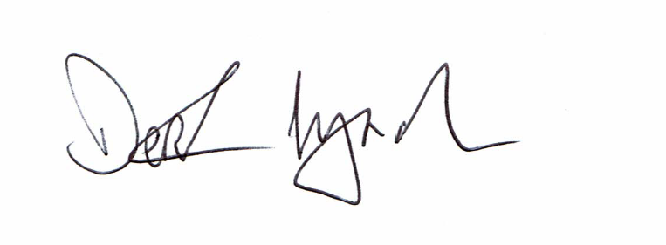

Secretary

6/9/24