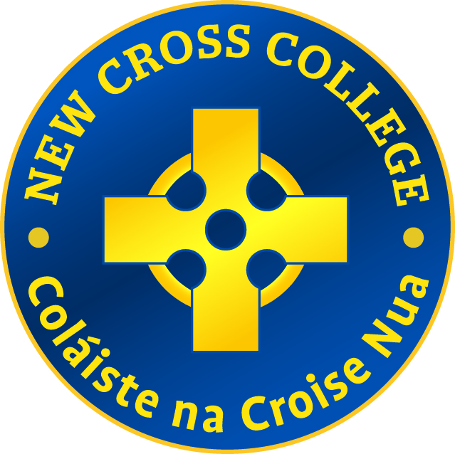

New Cross College
School Book Rental Scheme

Aim
That all students are facilitated to have text books at minimum expense to their parents
Background
A book rental scheme was established in both Patrician College and Mater Christi schools prior to the amalgamation and has remained in existence for New Cross College following consultation with staff and parents. In the early stages a small number of standard text books were provided through the scheme. All students avail of the scheme. The Book Rental Scheme covers purchase of books, materials for practical subjects, insurance, school journals, calculators, some travel costs and other stationery for classes.
Current practice
Parents are informed in March/April of the cost of the rental/charges for the upcoming year. Parents of incoming students are informed when an offer of a place in the school is being made (December/January). Traditionally payment is due by June for all attending students. Incoming students are asked to pay by May.
Annual Charges
1st year - €280
2nd year and 3rd year - €200
Transition Year - €300
Leaving Certificate Applied - €150
Leaving Certificate Traditional - €250 -5th year €200 – 6th year
Maximum Family Charge which also includes other school charges - €600
The annual grant from the DES is distributed throughout the school and covers the shortfall caused by families unable to pay
Parents have the option to pay by instalment.

Non -payment of Book Rental
Where families have difficulties paying the book rental cost, contact with St Vincent De Paul is arranged. In other cases we ask that the families pay in small instalments where possible. Where no effort is made to pay the book rental, reminder letters are sent and if necessary, followed by phone calls.
Procedure
Teacher subject groups meet in March/April to decide on text book requirements for the upcoming year. Where possible the existing stock of text books is used
A final list for each year group/subject is presented to the principal before the end of May
For this system to work effectively and efficiently the school needs to know the composition of all subject groups in each year by mid-May Third Year, Transition Year and Sixth Year students return all texts at the conclusion of the State Examinations/year
Outgoing First Year, Second Year and Fifth Year students do not return their texts in May, unless requested by subject teacher
Purchasing books
Books are purchased, where possible, from a sole supplier, in line with the JMB procurement procedure
Maintenance
Students are actively encouraged to take proper care of texts on loan to them by the school
Stocktaking of all books returned is carried out annually and the condition of books is monitored. At this stage a decision is made by the book rental personnel, in conjunction with subject teachers and the principal, as to whether the stock of any particular text is of sufficient quality to be issued again. If deemed unusable they are sent for recycling
Distribution of books
Subject teachers procure books for their classes by completing an order slip which is passed on to the book rental coordinator for processing.
Texts are allocated by book rental personnel having been counted, scanned and checked. Teachers collect them from the book store and distribute to class
Return of books
Books are returned back into the system when students have finished using them
If books are not returned the book rental person follows up on same
The cost of lost/excessively damaged books is borne by the student/parents
Maintenance of books
Students are responsible for all textbooks issued to them by the school. While all textbooks remain the property of the school, students are required to handle them with care.
Subject teachers play a vital role in ensuring the care and condition of textbooks.
Note
Workbooks and examination papers are not supplied by the scheme.

Chairperson signature
___________________________
Noel Merrick

Date ______________________

